# **Homework 2**

# **Instructions:**

**There are 6 questions in this assignment. Provide your answers on the provided answer sheet). For questions requiring diagrams, put your name somewhere on the diagram and copy and paste the image of the diagram into the answer sheet.**

The IT team at Game Technology prepared DFDs for the new C3 system. You will help the team develop a set of object models. The C3 system model will include use cases that represent various business processes. The customer and sales rep entities will be actors, with these methods:

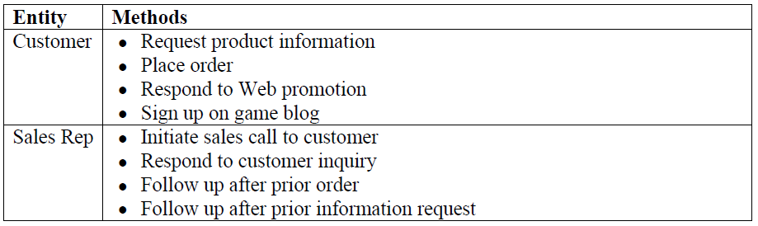

You also learned that customer categories are based on specific conditions, as shown:

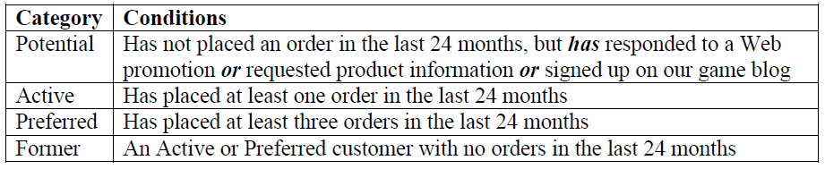

1. **Draw a use case diagram that includes the entities and the use cases.**

**(paste your image on the answer sheet provided)**

1. **Create a class diagram based on the use case diagram.**

The Human Resources Department for Game Technology is interested in developing some improvements to the system used to process employee vacation requests. The vacation request process works as follows:

The employee fills out a vacation request form. After completing the form the employee submits the form for approval to the manager. Next the manager reviews the requests. If the manager approves the request, the manager notifies the employee then routes the form to HR. HR receives the form, enters it into the computer, and files the original. The request process ends. If the manager denies the request, the manager notifies the employ that the request is rejected and the request process ends.

1. **Create a business process model of the vacation leave process (paste your image on the answer sheet provided)**

The IT team at Game Technology is moving forward with the new Customer Contact Care information system, or C3. Your next assignment is to develop a set of data flow diagrams (DFDs). To be sure you can handle the tasks, you decide to review Chapter 5 of your systems analysis textbook. Based on your requirements model, you know that the new C3 system will have three external entities, with the following data flows:

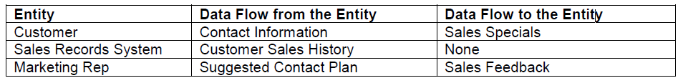

The **C3** system also will have three processes (**Analyze Customer Data**, **Analyze Sales History**, and **Manage Contact Plan**), a data store (**Customer Profile)**, and the following data flows:

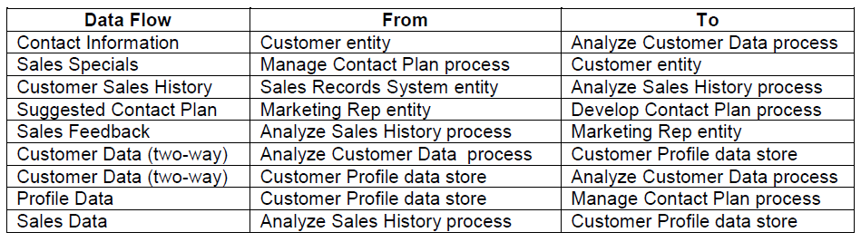

1. **Draw an ERD diagram. Indicate the entities, primary keys, and relationships.**

**(paste your image on the answer sheet provided)**

The IT team at Game Technology is working on an overall architecture for the new C3 system. They solicited RFPs from several hardware vendors, and decided to work with Network Illusions, a well-known local firm. Your job is to help analyze the server test results, and to draw network diagrams when requested.

The Network Illusions sales rep recommended a Model DX server for the C3 network, and submitted the following data, which shows projected network response times for various numbers of Game Technology users:

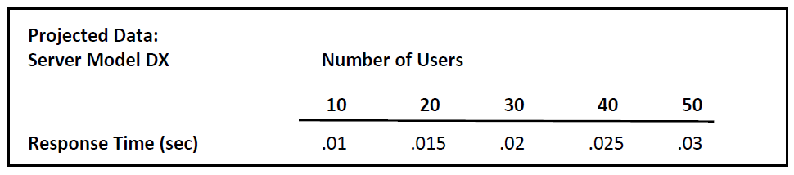

1. **Using the data provided, create a chart in Excel that shows Response Time on the Y (vertical) axis and Number of Users on the X (horizontal) axis. Describe the results and your interpretation of the data.**

**(Provide your answer on the answersheet provided)**

1. **Draw a bus network with a server, six workstations, a printer, a scanner, and a wireless access point (WAP).**

**(paste your image on the answer sheet provided)**